Sony Music Publishing Cloud Services
SMP_Cloud_Operations@SonyMusicPub.com

Redshift query editor
V 1.0.0

Table of Contents
Overview 2
Access to redshift query editor 2
1 OKTA access 2
2 AWS access 2
3 Query Editor 4
4 Running Queries 7
5 Exporting Data 8
6 Unload Command 9
7 Accessing the Data in S3 10
Appendix 12
Revision History 12

Overview
This document contains instructions for business users to access and use Redshift Query Editor (RQE).
Query Editor is the SMP approved tool for querying the Self-Service Redshift Database Cluster which contains a number of business-facing data entities (views and tables) which can be directly queried.
Request concerning this document should be sent to SMP_Cloud_Operations@SonyMusicPub.com.

Access to redshift query editor
Access to Redshift Query Editor is provisioned for SMP users via OKTA.
OKTA access needs to be provisioned first, followed by access to specific AWS accounts and roles.

1 OKTA access
Access to Redshift Query Editor is provisioned for SMP users via OKTA. If you don’t have access to OKTA it can be requested via the Sony Helpdesk IT Help Desk - Jira Service Management (atlassian.net)
Select OKTA from the Software Applications Dropdown
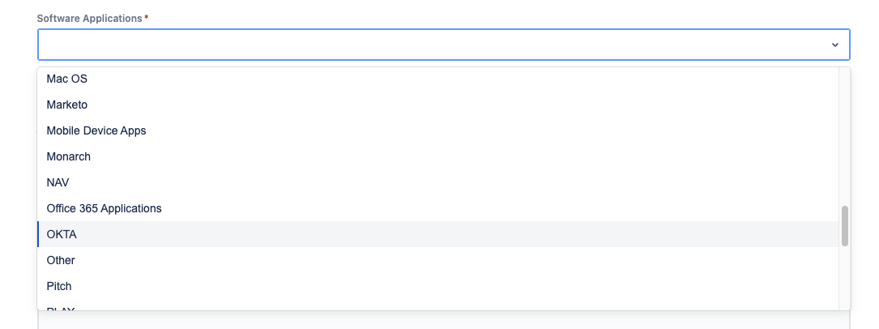

2 AWS access
Redshift Query Editor is currently available in the production environment only. The environment contains data spanning multiple business areas, so access is further controlled using security roles.
Roles
Group Description | Group Name | Owner
Global Analytics | dw_self-service_global_analytics_prod | Miguel Colmenares
Proactive Matching | dw_self-service_proactive_matching_prod | Miguel Colmenares
Deal Investment | dw_self-service_deal_investment_prod | Miguel Colmenares
Portfolio Analysis | dw_self-service_portfolio_analysis_prod | Miguel Colmenares
Chart Share | dw_self-service_chart_share_prod | Miguel Colmenares
AR Research | dw_self-service_arresearch_prod | Miguel Colmenares
Digital Licensing | dw_self-service_digital_licencing_prod | Miguel Colmenares
Financial Planning | dw_self-service_financial_planning_prod | Miguel Colmenares
Global Royalty Centre | dw_self-service_global_royalty_centre_prod | Miguel Colmenares
Global Copyright Admin | dw_self-service_global_copyright_admin_prod | Miguel Colmenares
Local Copyright | dw_self-service_local_copyright_prod | Miguel Colmenares
Local Royalties | dw_self-service_local_royalties_prod | Miguel Colmenares
Client Analysis | dw_self-service_client_analysis_prod | Miguel Colmenares
Sync Admin | dw_self-service_sync_admin_prod | Miguel Colmenares

- Identify the required role from the list above. The roles are split by business persona.

- Access My Apps Dashboard | Sony Music Publishing (okta.com) and select the OKTA Access Requests Icon.

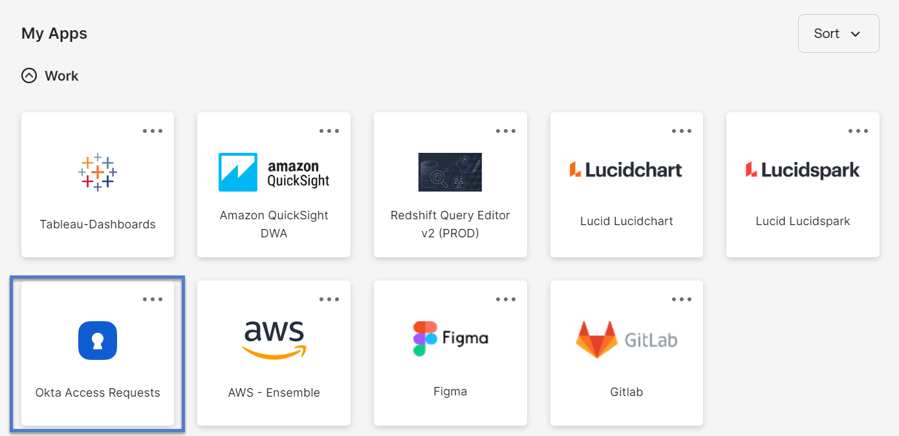

- Select Data Warehouse – Business

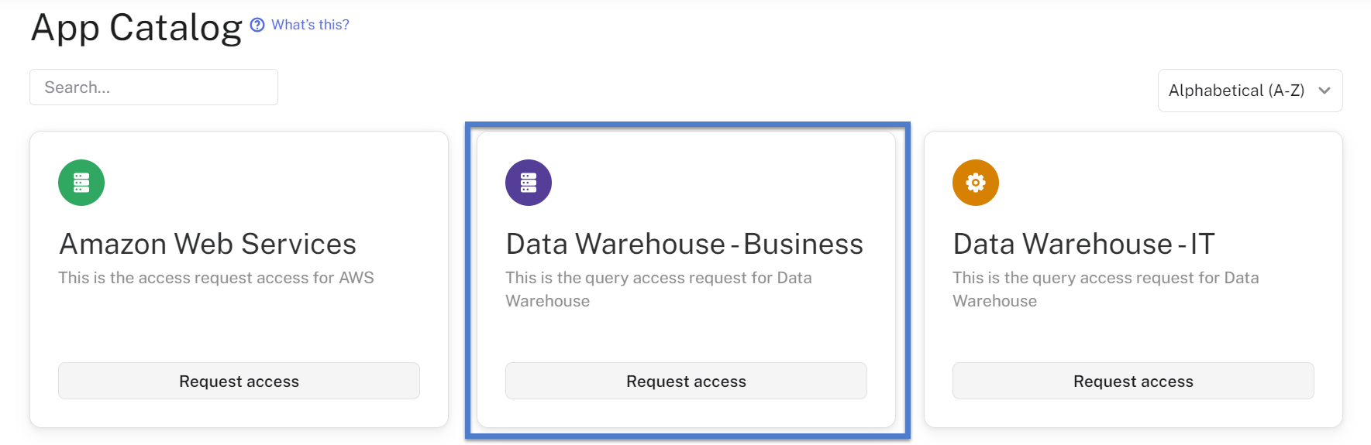

- Select the required role from the list and provide justification
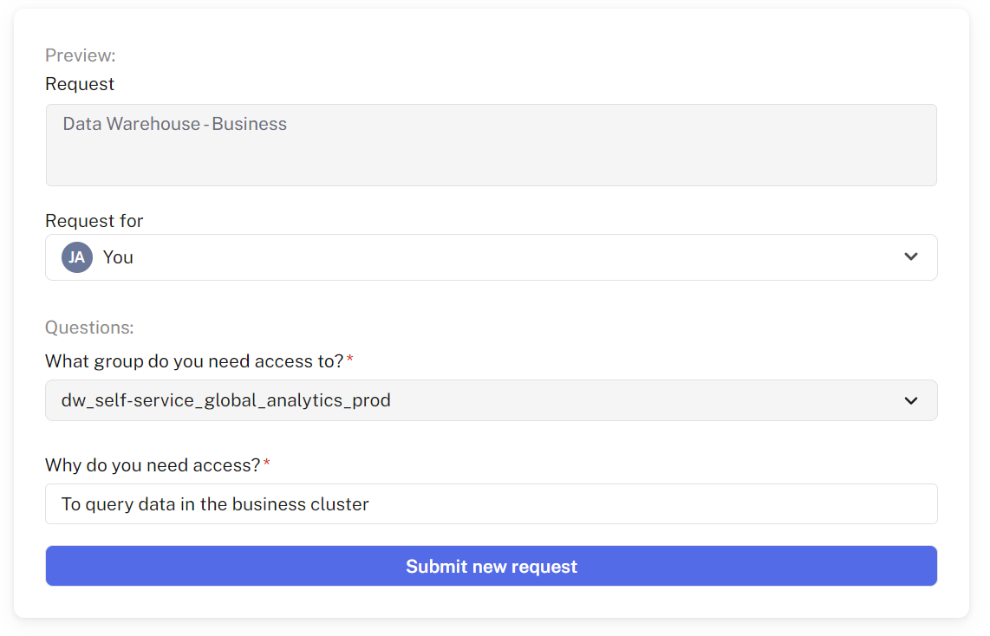
- Once submitted, the request will be sent to the owner for approval. Email notification will be provided when the request is approved or denied.

3 Query Editor
Once the OKTA role request has been approved, an AWS account will be created for you. You use the AWS console to open and use the Query Editor.
- Access My Apps Dashboard | Sony Music Publishing (okta.com) and select the AWS Ensemble Icon.
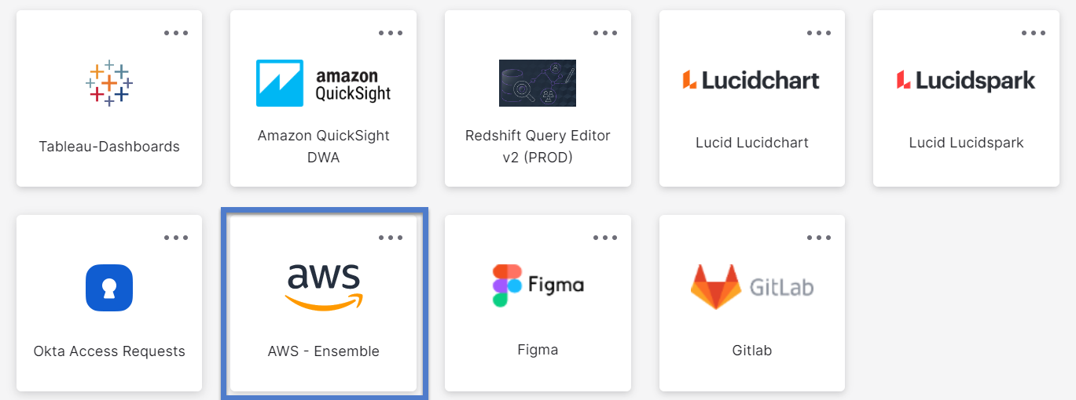

- Select the production AWS account and choose tool RedshiftQueryEditorV2.

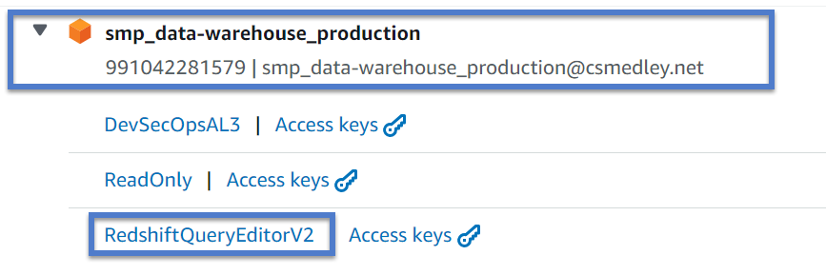

- The query editor will open. The connection for self-service is serverless: self-service-prod-wg.

It can be selected from the connection pane on the left of the query editor window. The connection and database are also set above the query pane. You should check these are set before running a query. The database name for self-service is
selfsvcdb.

NOTE – For Redshift Query Editor to successfully connect to our data environment, you need to ensure your browser’s 3rd party cookies are enabled.

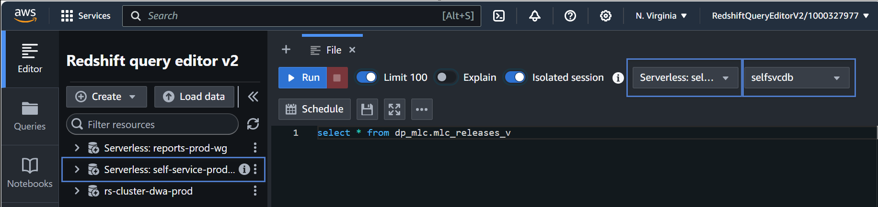

Important Note
When you first launch the query editor your connection may have timed out. AWS are working towards a fix for this issue.
If your session has timed out, you will see this message:
To re-establish your connection, follow these steps:
    - Click the ellipsis next to the connection name and delete it.
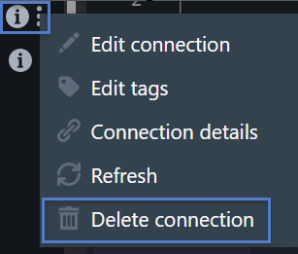

    - Click the ellipses again and re-create the connection.
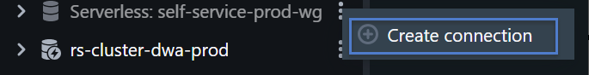
    - Continue with the defaults to re-create the connection.
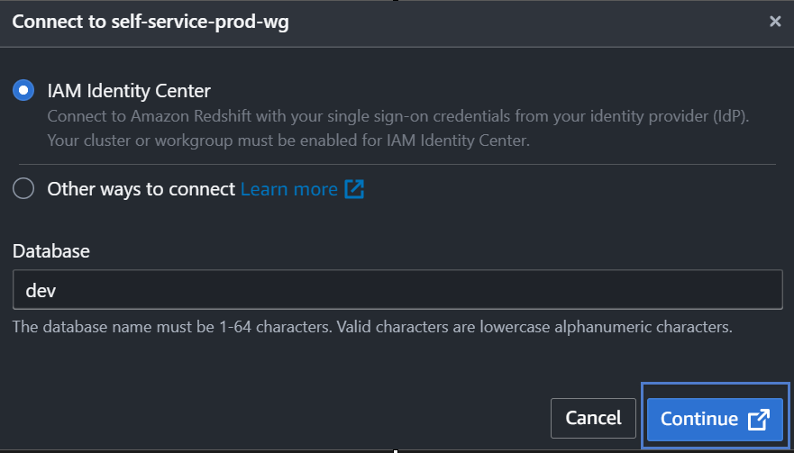

    - Select the correct database selfsvcdb.
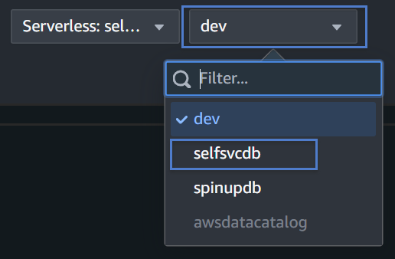

4 Running Queries

Query Editor Pane: This is the main area where you write and edit your SQL queries. It provides syntax highlighting, auto-completion, and other editing features to make writing SQL easier.

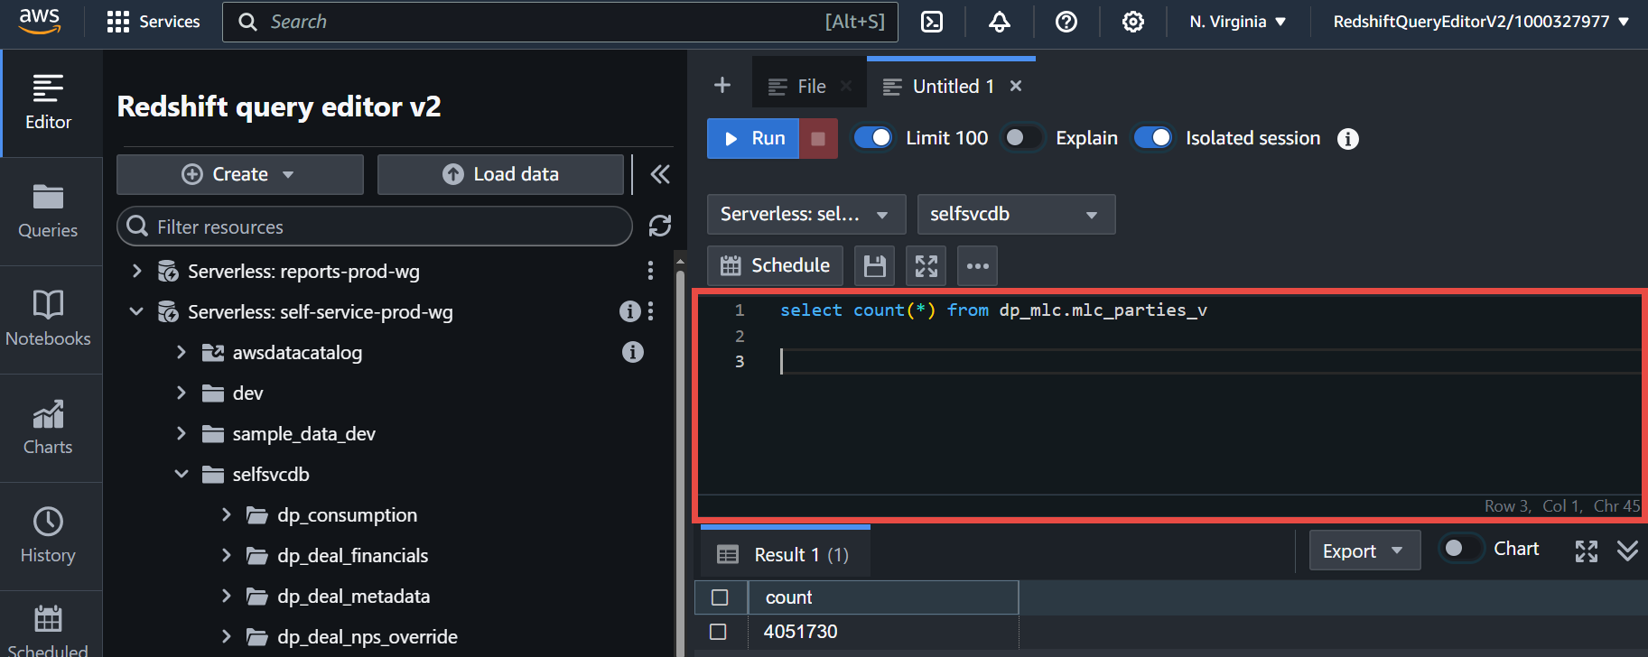

Results Pane: After running a query, this pane displays the results in a tabular format. It shows the data retrieved by the query, with columns and rows.
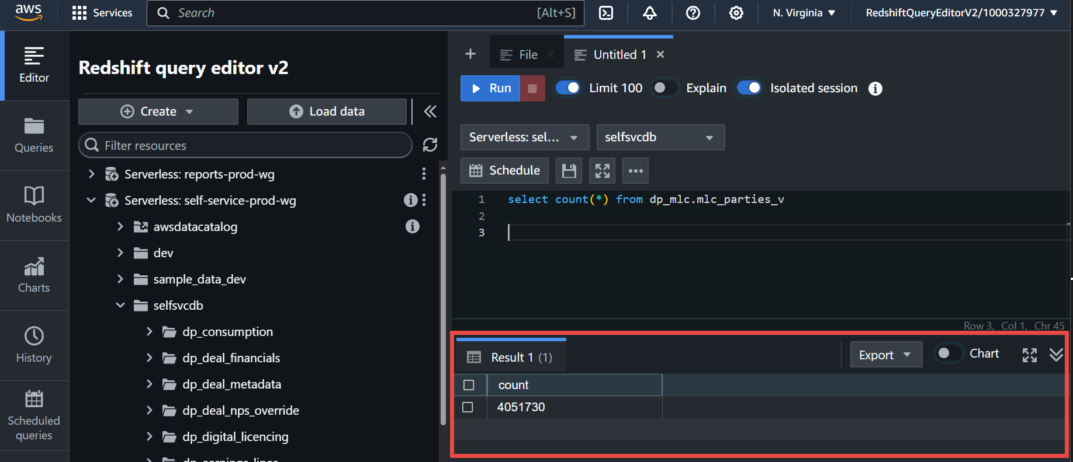

Schema Browser: This pane provides a tree view of the database schemas, tables, and other objects. It allows you to explore the database structure and drag-and-drop tables or columns into the SQL Editor.

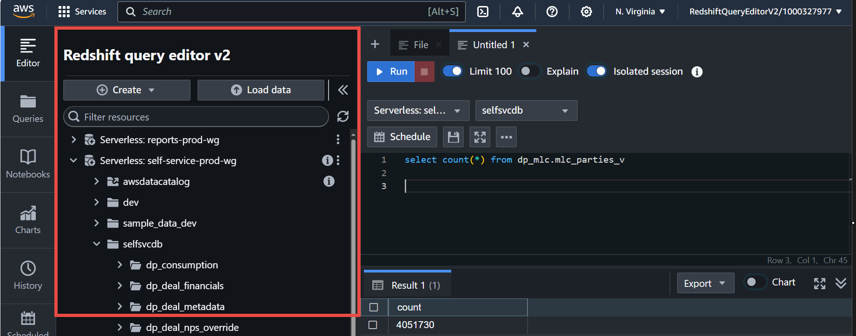

5 Exporting Data
Redshift Query Editor V2 has specific limitations on the size of query results that can be displayed directly in the editor. These limitations ensure optimal performance and useability for users interacting with large datasets.
Result size limits:
The editor has a maximum result size of 100,000 or 10MB whichever is reached first.
Handling large requests:
If a query exceeds these limits, it will not display all the rows. Instead, you will need to adjust your query to return a smaller result set. For large datasets you can also use the unload command to export the data to Amazon S3 for further analysis.

6 Unload Command

Basic Syntax for UNLOAD
- The select statement should be enclosed in single quotes.
- The S3 ‘to’ location will always be 's3://dw-export-prod/<GID>/<File Name>
- The IAM role will always be 'arn:aws:iam::991042281579:role/DataWarehouse/RedShift-S3-Unload'
You can use optional parameters:
DELIMITER: Specifies the delimiter to use in the output file.
DELIMITER [delimiter-character]
FIXEDWIDTH: Specifies fixed-width output format.
FIXEDWIDTH 'column1-width,column2-width,...'
ADDQUOTES: Adds quotes around the output fields.
ADDQUOTES
NULL AS: Specifies a string that represents NULL values.
NULL AS 'null-string'
ALLOWOVERWRITE: Allows the command to overwrite existing files.
ALLOWOVERWRITE
PARALLEL: Specifies whether to use parallel unloading. Can be set to ON or OFF.
PARALLEL [ { ON | OFF } ]
MAXFILESIZE: Specifies the maximum size of each file in the output.
MAXFILESIZE [size]
HEADER: Adds a header row to the output file with column names.
HEADER
Example command using optional parameters:
UNLOAD ('select * from dp_mlc.mlc_parties_v')
TO 's3://dw-export-prod/100000000/filename.csv'
IAM_ROLE 'arn:aws:iam::991042281579:role/DataWarehouse/RedShift-S3-Unload'
DELIMITER ','
ADDQUOTES
ALLOWOVERWRITE
HEADER
FORMAT as CSV
NULL AS ‘empty’

7 Accessing the Data in S3

Once the unload command has run, you can access the result set by following these steps: Note that results will be retained in the S3 bucket for 7 days only before they are removed automatically.
- Confirmation the command has run successfully will be displayed in the query editor.


- From the console window search for the S3 tool. Right click to open I a new browser tab
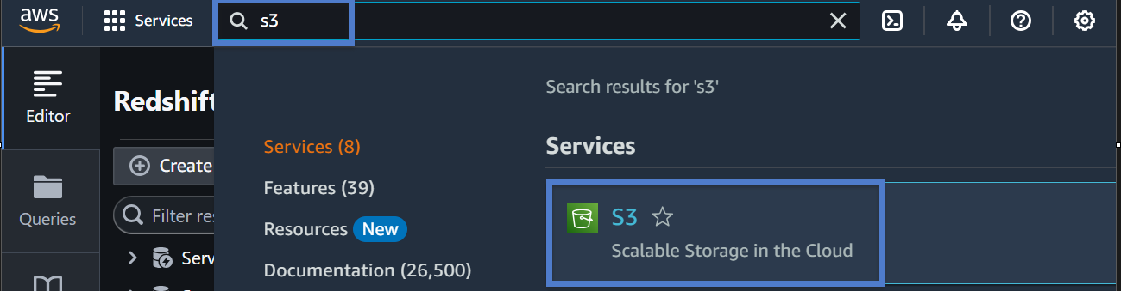

- Locate the shared export S3 bucket.
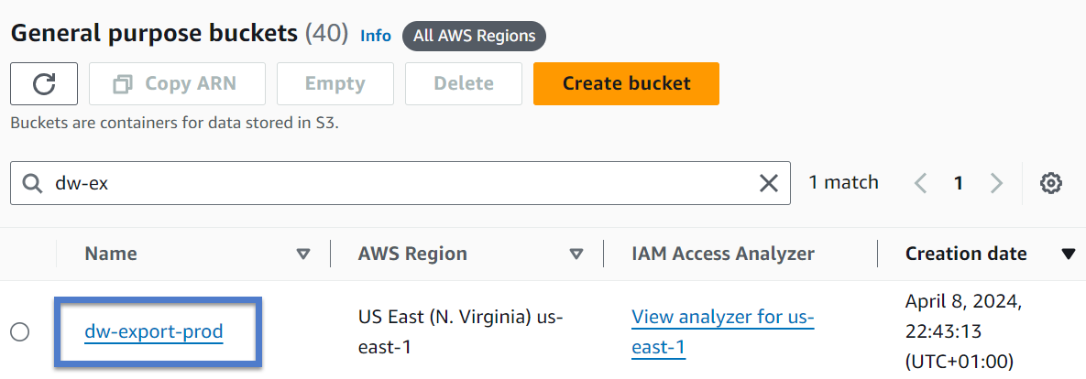

- Locate the exported file within your GID folder.
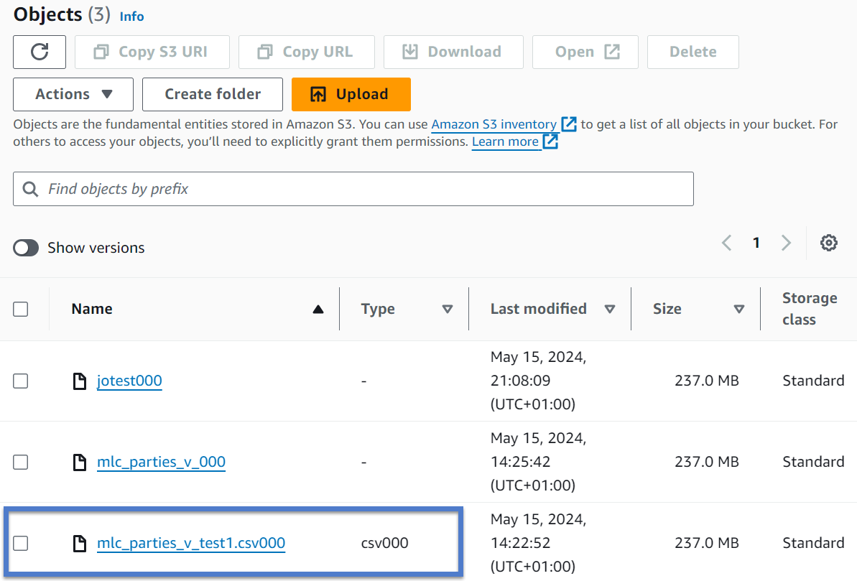

- Hit download to get the data.
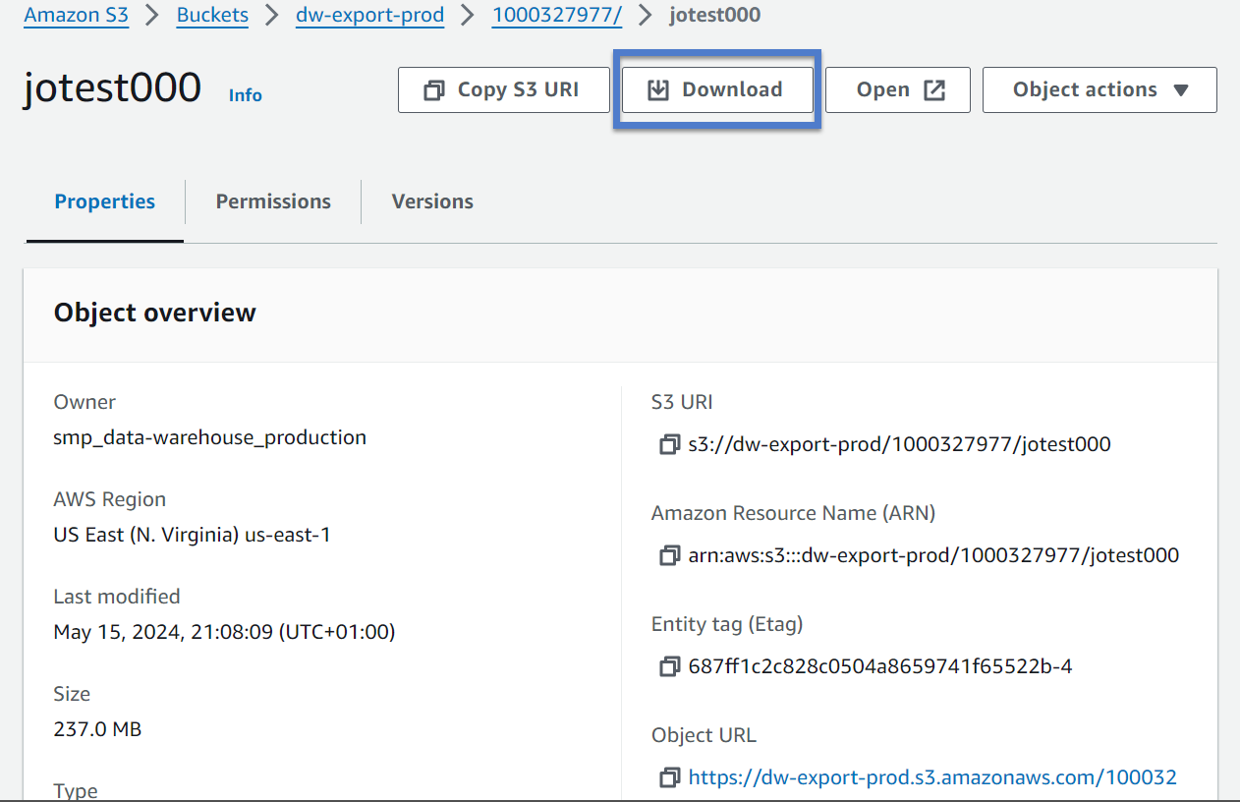

Appendix
Redshift Query Editor Documentation
Redshift Query Editor V2
Unload Command Documentation
UNLOAD - Amazon Redshift

Revision History
Date | Author(s) | Version |  | Comment
2024-05-14 | Joanna Adde | V1.0.0 |  | First Baseline version

